Assignment Day 18

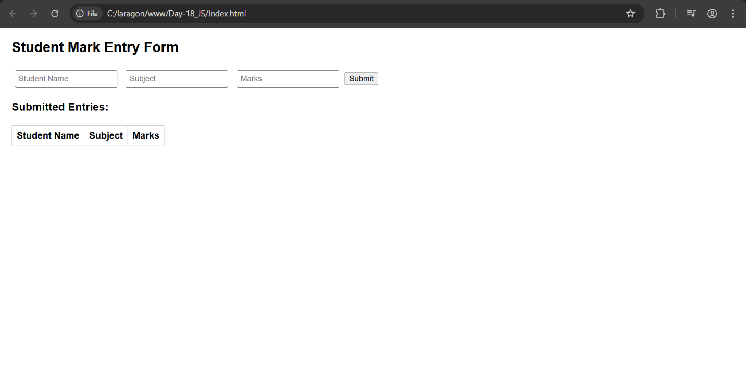

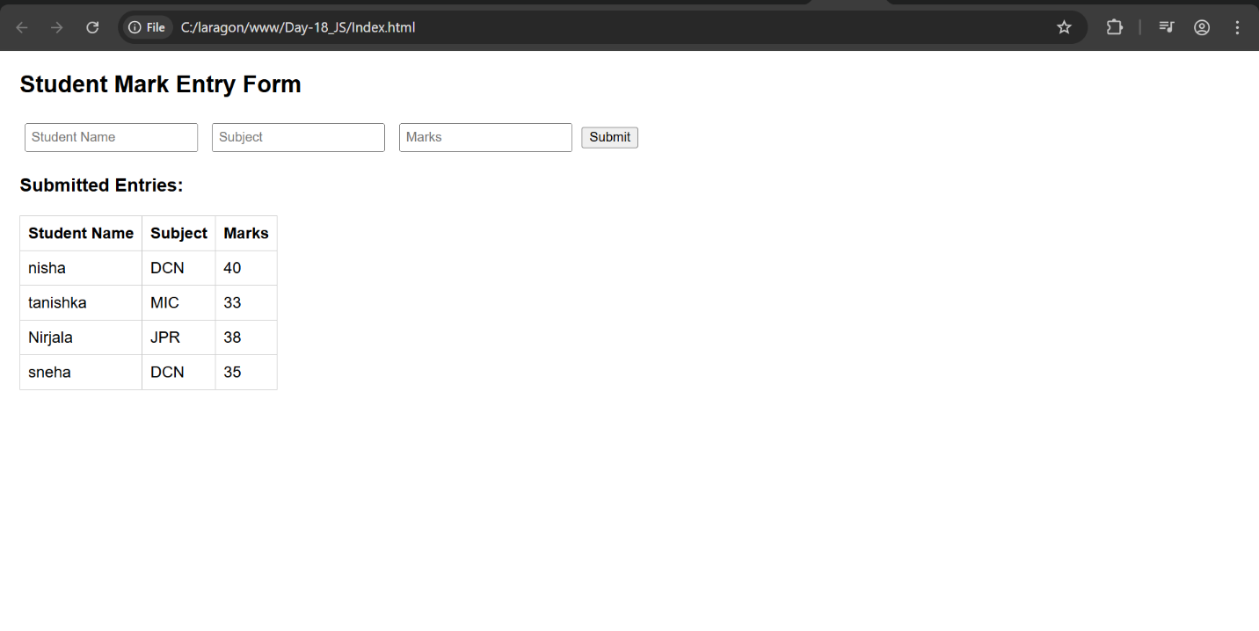

**SQL commands:**

CREATE TABLE student_marks (

id INT AUTO_INCREMENT PRIMARY KEY,

student_name VARCHAR(100) NOT NULL,

subject VARCHAR(100) NOT NULL,

marks INT NOT NULL CHECK (marks >= 0 AND marks <= 100)

);